Online Reflection and Evaluation (ORE)

An Assessment and Reorientation Tool

Ore is the raw material from which metal is extracted. To do this, the ore must first be found and mined. Then it is processed, refined, and purified. Figuratively speaking, this process also applies to our lives. Our experiences are like ore. They contain potential that, with effort, can be extracted and put to profitable use.
That is what this tool is about. The idea was born during the 2020/21 pandemic, when face-to-face meetings were not possible due to restrictions. ORE is a tool that makes it possible in a simple way to determine the current situation. Where appropriate, this may lead to specific steps for change. The acronym ORE stands for Online Reflection and Evaluation. ORE does not replace an in-depth debriefing, but it enables a simpler evaluation with reflection.
Ideally, ORE is used in three consecutive personal interviews on location. However, it also works via an internet platform. The tool is intended for use in a conversation between two people but can also be used for self-evaluation. In this case, it needs to be adapted in some places.
We wish you joyful and open conversations while using ORE, as well as insight and ideas that lead to new growth.

With warm greetings,
Franziska Hornstra-Fuchs
Brigitte Schönenberger
Wildberg, Winter 2021

Franziska Hornstra-Fuchs has worked in leadership and leadership development with an international ministry for many years. She is a trained debriefer and coach. Franziska and her husband, Wilrens, live in the south of Germany at the edge of the Black Forest, where they offer a place for people to come for personal retreats and debriefing (Elijah’s Inn, www.elijahsinn.org).
Brigitte Schönenberger has lived many years in North and West Africa where she has been working with vulnerable women and children. She is currently based in her home country where she is involved in staff care and development within an international ministry that is training cross-cultural workers.

Copyright: CC0 1.0. To the extent possible under law, Franziska Hornstra-Fuchs and Brigitte Schönenberger have waived all copyright and related or neighbouring rights to “Online Reflection and Evaluation (ORE): A Tool for Occupational Positioning & Reorientation”. This work is published from: Germany.
In plain language: You may do with this material whatever you like.
Visit www.elijahsinn.org for more information.

Framework
In this section, we present the framework of ORE. Subsequent sections explain the process step by step.

Which target group does this tool serve?
ORE serves people:
- Who follow Jesus.
- Who want to grow.
- Who are open to change and to set new goals.
- Of all ages.

For what reason do people make use of ORE?
- They want to take stock of where they are at.
- They feel a certain dissatisfaction and want to find a better way.
- They are concerned with the question of whether they are still in the right place.
- It is offered to them in a MemberCare process.
- It is used as a tool in a job or ministry evaluation in a Christian church or organisation.

How else can the tool be used?
- The tool can be used in a one-on-one conversation with a friend (peer to peer); both answer the questions.
- It can be used for self-reflection (e.g., as a yearly review).

What is the tool for?
- The tool serves as a compass. It helps to find out: Is my direction right? Am I still on the right track?
- It helps to recognise potential and possible needs for change and to put the insights gained into practice.

How does it work?
ORE evaluates and reflects on four areas of life from the following three perspectives: Where do I come from, where am I now, and where do I want to go? At the end of the process, the participant has evaluated the following areas:
- Their relationship with God.
- Their relationship with themselves.
- Their vocation; this includes how the participants apply their potential to their tasks.
- Their relationship with others.
In the end, the person has identified:
- What is going well.
- What needs correction or adjustment.
- What options there are for correction.
In addition, the person has set at least one practical goal to which they are committed and that will lead to positive change.

What is the time commitment for this tool?
The process is divided into three sessions of one to two hours each. Depending on the interviewees, the process can be longer or shorter. The questions serve as impulses for the conversation. They can be expanded at any time and adapted to the person or situation. The length of time needed will, of course, depend on this.

The Process
How to use this tool? What follows below is a step-by-step explanation of the process. There are three task sheets (see appendix). These sheets are used as the basis for the second and third interviews. Ideally, the sheets are completed in advance.
The questions serve as impulses for the conversation. They may be adapted to the interview partner. Ideally, this leads to a natural conversation. There should be room to “think out loud”, which usually happens based on further questions that arise from the conversation.
The questions listed therefore serve more to provide direction, as a rough guide, rather than as an exact prescription to be followed.

First Session: Introduction and Relationship with God
The first session contains an introduction, a time of meditation on a Bible passage (e.g. Lk. 15:11-21), and the first round of evaluation. Overall, the focus is on the first area of life: one’s relationship with God.

Getting Started
The beginning depends on the conversation partners. If you do not know each other, it is worthwhile to first allow time to get to know each other. You can also ask about expectations or clarify possible questions. The introduction may also include a short prayer.

Opening Meditation
A suitable passage for an introduction is Luke 15:11-21, part of the parable of the prodigal son. This can be done in different ways. Here are two possibilities:
- Read the text together and talk about it.
- Take time to reflect on the text. The leader reads the text slowly and pauses after each sentence (about 30 seconds). The participant focuses on the younger son during this process, either as an observer of the situation or as one who looks at the text from the son’s perspective. Allow the text to make an impact by making an inner picture of what is heard as if one were watching a movie. It may be helpful to ask the following questions after each sentence: What do you see? What do you hear? What do you smell? What do you taste? What do you feel? You put yourself in the text and let the events affect you. Afterwards, you take time to share.
The continuation consists of an open conversation.

Relationship with God
As followers of Jesus, we desire growth, regardless of how long we have been on the journey with Him. We want to deepen our relationship with God and do His will. This is discipleship.
The following questions are intended to stimulate reflection. They do not necessarily have to be asked in full or asked verbatim. They serve as possible aids to verbal reflection and are intended to give direction to the conversation. Often further questions arise from the course of the conversation. However, the goal must not be lost sight of. Those reflecting must conclude by coming up with practical steps for how they may grow in their spiritual lives over the next few months.
- On a scale of 1-10 (10 = almost perfect), how do you experience your relationship with God?
- What makes it a ... (e.g. a seven)? Please describe.
- What is life-giving in your relationship with God?
- What are you dissatisfied with?
- How do you feel about it?
- What is missing that would make you rate the relationship higher? How could you increase the rating by one or two points?
- What in your life reflects who God is? Where is the image distorted?
- List two or three ideas on how you could grow in your relationship with God over the next six months.
- …
- …
- …
These ideas are written down. Towards the end of the third session, they are taken up again in conversation.
The continuation of the process is made easier if the following two handouts are worked through in advance (i.e., before the second session). The time required is 10-15 minutes each.
- How do you describe yourself? Refer to the first appendix with Handout A. This handout helps to reflect on the area of relationship to self. Which seven to ten adjectives best describe you?
- How do you see your calling and how do you express your potential in your tasks? See the second appendix for Handout B. Which three to five terms best express how you would describe your area of responsibility? Underline the adjectives that describe how you perceive this.
As a conclusion, you can pray briefly.

Second Session: Relationship with Oneself and Vocation
The second session covers two areas of life: relationship with oneself and vocation. Vocation also includes the extent to which one’s potential contributes to and is utilized in one’s tasks and responsibilities. It is a good idea to start with a short prayer.

Relationship to Oneself
The first question is how well the participants know themselves and to what extent they live in accordance with this knowledge.
As in the first area, the task is to stimulate reflection by asking questions about the topic. These questions do not necessarily all have to be asked or asked verbatim. They serve as possible aids to verbal reflection and should give direction to the conversation. Often further questions arise from the course of the conversation. However, the goal must not be lost. Those reflecting must conclude by coming up with practical steps how they can grow in the coming months.
If the handout was worked through before the second session, it will help the conversation.
- What terms in the handout describe you?
- What qualities do you experience as positive? Which ones serve you well?
- Which characteristics are stumbling blocks for you?
- To what extent can you be yourself? To what extent do you bend yourself or pretend to be different from what you are?
- What needs your attention in the near future? Where do you wish for change?
- How could you get closer to this goal in the next six months? Be as specific as possible.
- …
- …
- …
These practical possibilities are written down. Towards the end of the third session, these are revisited in conversation.

Vocation
The third area of life deals with what God has given and entrusted to someone. How responsibly does the person handle tasks, roles, and resources? How do they manage their time, their energy, their talents, and their abilities? Where does it need adjustment and new direction? The second handout is meant as a help to become more aware of one’s attitude and perception towards one’s tasks.
As with the previous areas of life, the aim is to stimulate reflection by asking questions about the topic. These questions do not necessarily all have to be asked or asked verbatim. They serve as a possible help for verbal reflection and are intended to give direction to the conversation. Further questions often arise from the course of the conversation. However, the goal must be kept in mind. Those reflecting must conclude by coming up with practical steps for how they can grow in their vocation and involvement over the next few months.
- Where would you rank yourself on a scale of 1-10 in relation to your tasks? (dissatisfied/satisfied; joyless/fulfilled; careless, passive/responsible).
- What makes it a … (e.g. a seven)? Please describe.
- What would a 9 or even 10 (for the next two years) look like?
- What are two or three practical ideas that would help you move up one or two points on the scale?
- …
- …
- …
These ideas are written down. Toward the end of the third unit, they are revisited in conversation.
Possible follow-up questions:
- What ‘eats up’ your time or joy? What distracts you from what is really important?
- Are there dreams that you have put on the back burner, but that you should pay attention to?
- Are there priorities that should be changed?
- What keeps you most from being fulfilled in your work?
As a conclusion to the session, pray briefly.
Handout C should be worked through before the third session. The time required is 10-15 minutes. It deals with the topic of relationships with others. Each segment in the circle represents a category of relationships. The segments are filled in with different colours. The lighter the colour, the more positive and enriching the relationship is perceived; the darker the colour, the more difficult and conflictual the relationship is. The handout serves to make it easier to recognise which category of relationship they want to pay special attention to in the conversation.

Third Session: Relationship with Others and Implementation
In the first part of the third session, we look at relationships with the people around us. In the second part, we move on to practical application: What is there to celebrate? Which of the areas covered need increased attention in the coming months? What steps do we need to take to get there? Finally, there will be time for feedback and prayer.
Start with a short prayer.

Relationships with Others
Using Handout C, take a closer look at the different relationships.
- What characterises the brightest area (the brightest segment)?
- What in this relationship releases energy? What creates closeness?
- In which area would you most like to experience change?
- Describe this area.
- What drains your energy in this relationship? What creates distance?
- What are some ways and ideas to lighten up this segment?
  - …
  - …
  - …
These practical ideas are written down. They will be revisited in the next section.

Summary and Implementation
This second part of the third session is the final section of ORE. The focus is practical goals. What needs attention? Where is change needed? In the end there should be at least one specific goal (or two or three) that will be implemented in the next few months.
- In which of the four areas of life (relationship with God, with yourself, vocation, and relationship with others) is there reason to celebrate? What are the reasons?
- What could celebration look like?
- Which of the four areas needs your attention the most in the next six months?
- What will you do? Set two or three goals that you will pursue. Be specific.
  - Goal: ...
  - Goal: ...
  - Goal: ...
- Who could help and encourage you on this journey? To whom will you be accountable?

Conclusion
Toward the end, it is worthwhile to look back at the entire process again and allow for feedback. The following two questions may help:
- What helped you the most in this process?
- What could you (or I, or both of us) have done differently?
Finally, a blessing may be offered. You can also conclude with listening prayer to share a personal word for them to take with them on their journey.

Handout A: How do you describe yourself?
What am I like? Mark the seven to ten characteristics that most accurately describe yourself.

adventurous
anticipating
active
conforming
timid
undemanding
quick-tempered
sincere
persevering
balanced
authentic
merciful
Influenceable
enthusiastic
know-it-all
chaotic
charismatic
grateful
diplomatic
direct
aloof
disciplined
dominant
dynamic
efficient
ambitious
jealous
solitary
stubborn
emotional
touchy
decisive
relaxed
encouraging
imaginative
diligent
flexible
cheeky
freedom-loving
friendly
peaceful
cheerful
timid
hospitable
patient
obedient
stingy
skilful
talkative
conscientious
generous
thorough
greedy
tough
hard in taking
cordial
helpful
inspiring
intuitive
petty
clever
communicative
competent
complicated
confrontational
afraid of conflict
willing to compromise
conservative
sociable
critical
moody
eager to learn
affectionate
solution-oriented
loyal
manipulative
melancholic
shy
courageous
thoughtful
resentful
negative
nervous
curious
objective
open
optimistic
passive
positive
punctual
radical
realistic
opinionated
reflective
respectful
risk-taking
reckless
considerate
mischievous
sloppy
shy
silent
self-confident
self-critical
independent
carefree
frugal
spontaneous
team-oriented
spirited
thoughtful
sociable
independent
undisciplined
indecisive
insecure
entertaining
unreliable
sympathetic
cautious
wise
open-minded
goal-oriented
reserved
Created with the help of „Charaktereigenschaften“, https://wortwuchs.net/charaktereigenschaften/

Handout B: How do you describe your work?
Mark the three to five terms that best express how you perceive your work responsibilities.

abstract
diverse
pleasant
stimulating
demanding
frazzled
significant
inspiring
inspiring
comfortable
enriching
detail-heavy
detail-oriented
defined
ingrained
uneventful
success-oriented
fruitless
fascinating
captivating
deadlocked
flexible
demanding
joyful
profitable
resinous
challenging
ideal
intensive
interesting
paralyzing
boring
life-giving
people-oriented
monotonous
troublesome
sustainable
nerve-racking
laborious
gripping
non-stop
perfect
formative
frameless
relevant
factual
dragging
exciting
stagnant
steady
stressful
dull
stupid
overwhelming
overpowering
growth-promoting
impactful
time-consuming
time wasting ….
….
….

Handout C: My Relationships
How do I experience my relationships? Fill each segment with a colour: The lighter the colour, the more positive and enriching you perceive the relationship. The darker the colour, the more difficult and conflict-laden you perceive the relationship to be.

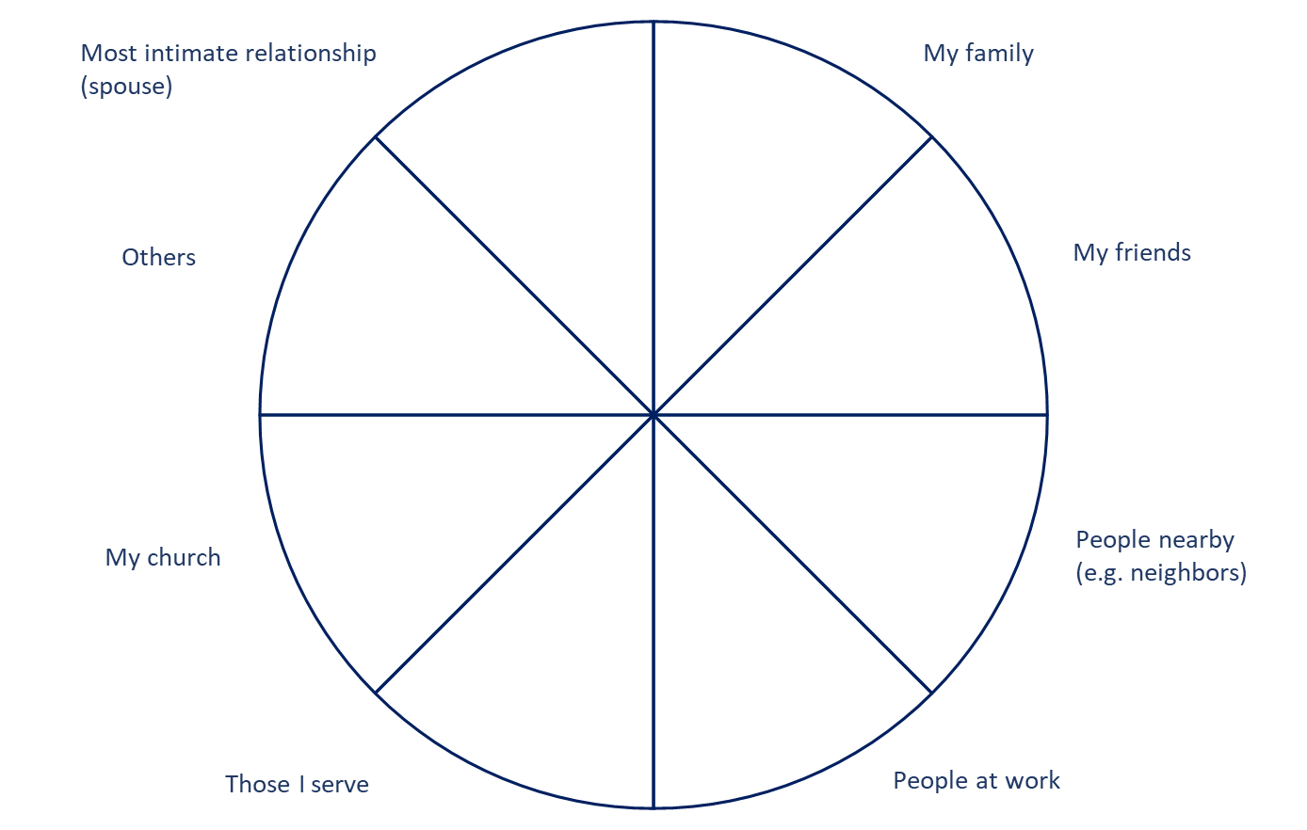

As mentioned in the introduction, using it for self-reflection requires some adjustments. In this case, it is especially worthwhile to record the answers in writing.
Of course, time can also be made available for these tasks during the interview.
Of course, other passages of Scripture lend themselves for this as well.
In case you need it, here is some help to understand the link to the ORE tool. The biblical text emphasises that the younger son, in his deep distress, reflects on his situation and draws conclusions from it, on the basis of which he makes a radical change. Some of the questions I have asked myself in my reflection are: How did the conversation between the father and the son go? What was the atmosphere when the younger son made his request? What may have been his motives? What was the relationship between the two brothers and the father? Why did he spend all the money? To what extent was he seeking recognition? What feelings (in addition to hunger) came when he ended up with the pigs? How long did he think before he made his decision to go home? How did he feel afterwards? What were his feelings and thoughts on the way back? Etc.
In no way should the conversation evoke the feeling of a test or be perceived as a quiz.
The aim should be to strengthen and deepen their relationship with God, not doing more for God.
We repeat: Under no circumstances should the conversation evoke the feeling of a test or be perceived as a quiz.
Even just noticing it and being happy about it is a form of celebration. You can thank God or tell a friend about it. You can pop open a bottle, etc.
Use the acronym SMART, which stands for the following criteria: S = Specific, M = Measurable, A = Attainable/Achievable, R = Realistic, T = Time-Bound.
For example, Aaron’s blessing in Numbers 6:24-26.

